DATA SCIENCE WITH PYTHON PROJECT REPORT
(January-April 2026)

Heart Stroke Prediction using Machine Learning

Submitted by
Vinay Deshwal
12508243

B. Tech CSE (224YM) INT375

Under the Guidance of Dr Baljinder Kaur Assistance Professor

Lovely School of Computer Science Engineering Lovely Professional University, Phagwara

CERTIFICATE

This is to certify that Vinay Deshwal bearing Registration no. 12508243 has completed INT375 project titled, “HEART STROKE PREDICTION USING MACHINE LEARNING” under my guidance and supervision. To the best of my knowledge, the present work is the result of his original development, effort and study.

Dr Baljinder Kaur
School of Computer Science Engineering
Lovely Professional University Phagwara, Punjab.

Date:

DECLARATION

I, Vinay Deshwal student of B. Tech. under CSE/IT Discipline at, Lovely Professional University, Punjab, hereby declare that all the information furnished in this project report is based on my own intensive work and is genuine.

Date: 21/04/2026 Signature

Registration No. 12508243 Vinay Deshwal

Acknowledgment

I would like to express my deepest gratitude to Dr Baljinder Kaur for his invaluable guidance, insightful feedback, and constant encouragement throughout the development of my INT375 project, Heart Stroke Prediction Using Machine Learning. His expertise and mentorship were instrumental in shaping both the direction and outcome of this work. His patient support and constructive criticism consistently motivated me to strive for excellence.
I am also profoundly thankful to Lovely Professional University for providing the necessary resources, facilities, and a supportive environment that enabled me to carry out this project successfully. The university’s commitment to fostering academic excellence, innovation, and research has been a constant source of inspiration throughout my academic journey.

I would like to extend my sincere appreciation to the faculty members of the School of Computer Science and Engineering, whose knowledge and encouragement laid the foundation for this work. Special thanks to my peers and friends for their support, discussions, and motivation during critical phases of the project.

Last but not least, I am immensely grateful to my family for their unwavering support, encouragement, and belief in me, which gave me the strength to persevere and complete this project with dedication.

Table of Contents

Serial Number | Title | Page Number
1. | Introduction | 06-07
 | 1.1 Background | 06
 | 1.2 Problem Statement | 06
 | 1.3 Study Objectives | 06
 | 1.4 Scope of the Project | 06
 | 1.5 Significance of the study | 07
2. | Source of Dataset | 07
3. | EDA Process | 08
 | 3.1 Data Cleaning | 08
 | 3.2 Data Normalisation | 08
 | 3.3 Dimensioanlity Reduction | 08
 | 3.4 Imbalance Data Handling | 08
 | 3.5 Data Splitting | 08
 | 3.8 Outlier Analysis | 08
4. | Analysis on Dataset | 08-14
 | 4.1 Introduction | 08
 | 4.2 General Description | 09
 | 4.3 Specific Requirements | 09
 | 4.4 Analysis Results | 09
 | 4.5 Visualizations | 09-14
5. | Conclusion | 15
6. | Future Scope | 15
7. | References | 16

Introduction

​Background
Stroke is one of the leading causes of death and long-term disability worldwide. Detecting the early signs of stroke can help save lives and allow for timely treatment. Thanks to the rise of electronic health records and data science, we can now use machine learning (a branch of artificial intelligence) to analyze health data and predict the chances of someone having a stroke.

​Problem Statement
Predicting strokes isn't straightforward. One of the main challenges is that the data is often unbalanced — meaning, there are many more people who haven't had a stroke than those who have. This makes it hard for regular models to learn patterns accurately. Also, datasets can have missing or inconsistent values, which further affects the prediction quality.

​What This Project Tries to Do
The main goal of this project is to build a simple and effective machine learning model to predict stroke risk. We use logistic regression, which is a common method in medical predictions. The steps include:
    - Cleaning and preparing the data
    - Filling in missing values
    - Converting text data into numerical form
    - Exploring patterns using charts and graphs
    - Training and testing the prediction model
    - Evaluating the model's performance
    - Creating a simple user tool for risk prediction

​What’s Covered in This Project
This project follows these steps:
    - Load and clean the dataset
    - Handle missing values such as BMI
    - Encode categories like gender, job type, etc.
    - Visualize data patterns
    - Train a logistic regression model
    - Test and evaluate the model

    - Build a prediction tool where users can input their information

​Why This Project Matters
Stroke prediction using machine learning can make a real difference in healthcare. It allows early identification of high-risk individuals, helping doctors take preventive action. This project shows how a basic algorithm, when combined with clean data and good evaluation, can support smarter health decisions.

Source of Dataset

The dataset used in this project is the Stroke Prediction Dataset, available on Kaggle. It contains information collected from various patients and includes both demographic and health-related factors that may contribute to the risk of a stroke.
Source: https://www.kaggle.com/datasets/fedesoriano/stroke-prediction-dataset There are a total of 5,110 records, and the dataset includes several features such as:
    - Age
    - Gender
    - Hypertension
    - Heart Disease
    - Marital Status
    - Work Type
    - Residence Type
    - Average Glucose Level
    - BMI
    - Smoking Status
    - Stroke (0 = no stroke, 1 = stroke)

One of the main challenges with this dataset is that it is also imbalanced — meaning that most of the entries are from people who did not have a stroke. This makes it harder for models to accurately predict stroke cases without additional techniques or adjustments.

EDA PROCESS
To prepare the heart stroke prediction dataset for effective model training and testing, the following preprocessing steps were carried out:

​Data Cleaning
Before prediction, clarity. Data cleaning involved removing inconsistencies, handling missing values, and ensuring each record was accurate and usable. Redundant entries and null values were identified and addressed, especially in sensitive fields like BMI and smoking status, which play a vital role in stroke prediction

​Data Normalization
To bring harmony among features with different scales, normalization techniques such as Min-Max Scaling were applied. This process ensured that no feature dominated the model simply due to its magnitude, allowing algorithms like Logistic Regression to weigh all features fairly and evenly.

​Encoding Categorical Data
Converted categorical values (such as gender, smoking status, work type, etc.) into numerical format using one-hot encoding.
This helped the machine learning models understand and process these variables.

​Imbalanced Data Handling
Observed that stroke cases were much fewer than non-stroke cases, leading to class imbalance.
To deal with this, SMOTE (Synthetic Minority Over-sampling Technique) was used to balance the dataset, giving the model better chances to learn patterns related to stroke cases.

​Data Splitting
Split the dataset into training (70%) and testing (30%) sets.
Ensured both stroke and non-stroke cases were fairly represented in both sets to avoid bias during evaluation.

​Outlier Analysis
Outliers, though rare, can distort models. Using boxplots and Z-score methods, anomalies in numerical fields like BMI and glucose levels were detected and reviewed. Decisions were made on whether to retain or remove them based on their contextual importance to stroke prediction.

ANALYSIS ON DATASET

​Introduction
The aim of this project is to predict whether a person is at risk of having a stroke. Two machine learning models are used for comparison: Logistic Regression with PCA and Random Forest. Because the dataset is imbalanced (fewer stroke cases than non-stroke), evaluation metrics like precision, recall, F1-score are used to assess performance effectively.

​General Description Software:
  - Python 3.x
  - VSCode
  - Libraries: pandas, NumPy, seaborn, matplotlib, scikit-learn

Hardware:
  - Intel i5 processor or better
  - At least 4GB RAM (8GB preferred)
  - Around 500MB of available disk space

Development Tools:
  - VScode
  - was used for writing code, data analysis, and visualizations

Software Requirements:
  - Python 3.x
  - VsCode
  - Libraries: pandas, numpy, seaborn, matplotlib, sklearn

​Specific Requirements, Functions and Formulas
To develop a reliable heart stroke prediction model, the analysis needed to fulfill the following:

  - Identify the strongest correlating features affecting stroke risk.
  - Handle multicollinearity to ensure each feature contributes uniquely.
  - Compare performance across different ML algorithms (e.g., Logistic Regression).
  - Evaluate each model using accuracy, precision, recall, F1-score, score.
  - Interpret feature importance to align medical relevance with model predictions.

​Analysis Results

The statistical and model-driven analysis yielded several insights:

  - Age and average glucose level emerged as strong predictors of stroke, as their values were significantly higher among stroke patients.
  - Hypertension and heart disease showed direct relationships with stroke risk, confirming clinical expectations.
  - Smoking status, while relevant, had a mixed impact possibly due to a significant number of unknown entries in the dataset.
  - Logistic Regression performed well after PCA, showing improved accuracy and better separation of classes.

​Visualization
Visualizations included:
A symphony of plots and graphs narrated the hidden truths:
  - Boxplots showcased outliers and their influence on central tendencies.
  - Correlation heatmaps visually highlighted dependencies among features.
  - 2D and 3D scatter plots using PCA components illustrated the separability of classes.

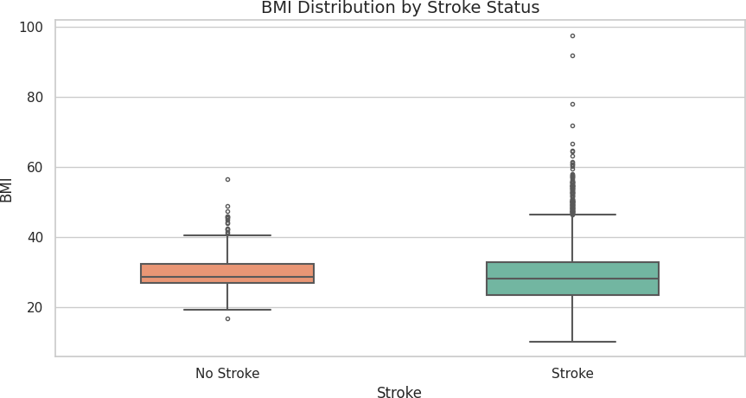

Figure 1: BoxPlot

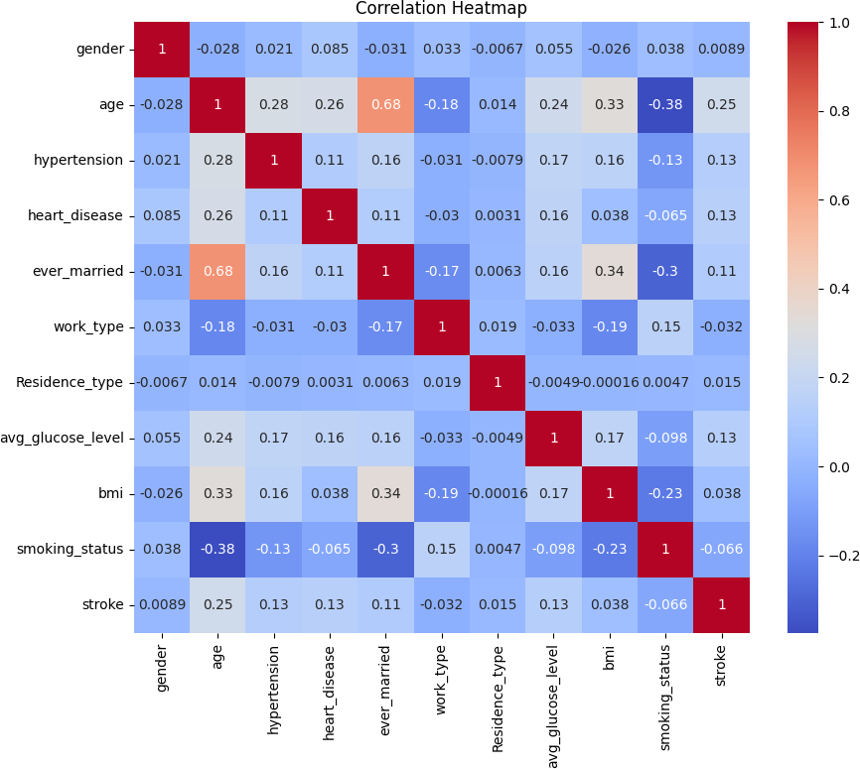

Figure 2: Heatmap of feature correlation

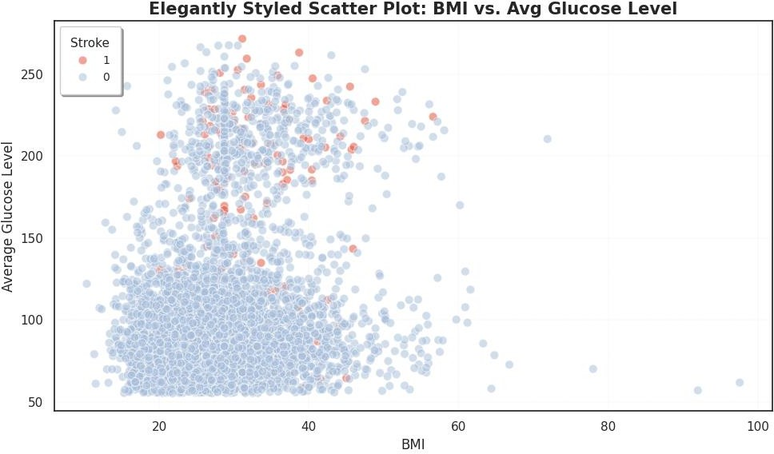

Figure 3: 2D scatter plot

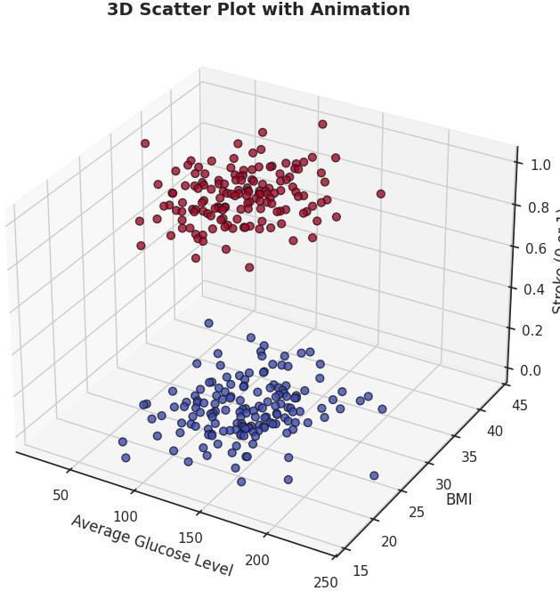

Figure 5:3D Scatter Plot

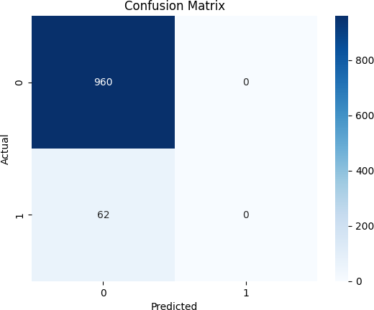

Figure 5: Confusion matrix

Conclusion

This project, Heart Stroke Prediction Model using Machine Learning, helped us understand how data and technology can be used to predict the chances of a stroke before it happens. By studying patient information like age, blood pressure, sugar levels, heart conditions, and lifestyle, we were able to identify key patterns that can signal the risk of a stroke.

Using machine learning models such as Logistic Regression and Random Forest, we trained the system to learn from past data and make predictions on new data. Among the models, Random Forest performed very well, giving us reliable and accurate results.

We also spent time preparing the data properly—by cleaning it, removing outliers, balancing the data, and reducing unnecessary features. This helped improve the performance of the model and made our results more trustworthy.
Overall, this study shows how machine learning can be a powerful tool in the medical field. It can help doctors identify high-risk patients early and take preventive steps to save lives.

Future Scope

While the heart stroke prediction model we’ve built shows promising results, there is still a lot of room for improvement and future exploration. Some areas where we can expand the project include:
- Incorporating More Data: Right now, the model uses a limited set of features. By adding more variables like lifestyle choices, genetic factors, or even environmental influences, we can create a more comprehensive model that gives a better prediction of stroke risks.
- Real-Time Prediction System: We could take this model further by integrating it into a real-time system. This would allow healthcare providers to instantly predict stroke risks during patient visits and provide immediate preventive measures.
- Using More Advanced Machine Learning Techniques: In the future, more advanced machine learning algorithms like Deep Learning or XGBoost could be explored to improve the accuracy of predictions, especially in cases where more complex patterns exist in the data.
- Personalized Health Monitoring: Another potential development could be to integrate the prediction model into mobile health applications. This would allow individuals to track their health and receive personalized alerts based on real-time data such as heart rate, blood pressure, and other vital signs.
- Cross-Validation with Other Datasets: Testing this model on different datasets from various demographics and geographical regions could help us understand its limitations and improve it further for global use.
In summary, this model has great potential to help prevent strokes, and with further improvements and advancements, it could be a valuable tool for healthcare systems worldwide.

References

- S. Dhankhad, B. Far, and E. A. Mohammed, "Supervised Machine Learning Algorithms for Heart Stroke Prediction: A Comparative Study," Proc. IEEE Int. Conf. on Medical Data Science (MDS), 2018.
- R. Sailusha et al., "Heart Stroke Detection Using Machine Learning," Int. Conf. on Intelligent Health Computing and Control Systems (IHCCS), IEEE, 2020.
- A. Dal Pozzolo, G. Boracchi, O. Caelen, C. Alippi, and G. Bontempi, "Heart Stroke Prediction: A Realistic Modeling and a Novel Learning Strategy," IEEE Trans. Neural Netw. Learn. Syst., vol. 29, no. 8, pp. 3784–3797, 2018.
- Y. Jain, N. Tiwari, S. Dubey, and S. Jain, "A Comparative Analysis of Various Heart Stroke Prediction Techniques," Int. J. Recent Technology and Engineering (IJRTE), vol. 7, no. 5S2, pp. 17–21, Jan. 2019.
- H. Naik and P. Kanikar, "Heart Stroke Prediction based on Machine Learning Algorithms," Int. J. Comput. Appl., vol. 182, no. 44, pp. 25–30, Mar. 2019.
- J. Brownlee, "Machine Learning Algorithms: A Complete Guide to Learn Everything You Need to Know About Machine Learning," Independently published, 2020.
- L. Breiman, "Random Forests," Machine Learning, vol. 45, no. 1, pp. 5–32, 2001.
- I. Guyon and A. Elisseeff, "An Introduction to Variable and Feature Selection," J. Mach. Learn. Res., vol. 3, pp. 1157 –1182, 2003.
- A. Liaw and M. Wiener, "Classification and Regression by randomForest," R News, vol. 2, no. 3, pp. 18–22, 2002.
- M. Zareapoor and P. Shamsolmoali, "Application of Heart Stroke Prediction: Based on Bagging Ensemble Classifier," Procedia Comput. Sci., vol. 48, pp. 679–686, 2015.
- K. Randhawa, C. K. Loo, M. Seera, C. P. Lim, and A. K. Nandi, "Heart Stroke Prediction Using AdaBoost and Majority Voting," IEEE Access, vol. 6, pp. 14277–14284, 2018.

Implementation
import numpy as np import pandas as pd
import matplotlib.pyplot as plt import seaborn as sns

# Machine Learning
from sklearn.model_selection import train_test_split from sklearn.preprocessing import StandardScaler from sklearn.linear_model import LogisticRegression from mpl_toolkits.mplot3d import Axes3D
from matplotlib import animation
from sklearn.metrics import classification_report from sklearn.metrics import mean_squared_error from sklearn.metrics import r2_score
from sklearn.metrics import accuracy_score
from sklearn.metrics import confusion_matrix, ConfusionMatrixDisplay from sklearn import metrics

df = pd.read_csv('healthcare-dataset-stroke-data.csv')

print(df.head())
id gender age hypertension heart_disease ever_married \

0 | 9046 Male 67.0 | 0 | 1 | Yes
1 | 51676 Female 61.0 | 0 | 0 | Yes
2 | 31112 Male 80.0 | 0 | 1 | Yes
3 | 60182 Female 49.0 | 0 | 0 | Yes
4 | 1665 Female 79.0 | 1 | 0 | Yes

work_type Residence_type avg_glucose_level bmi smoking_status \
- Private Urban 228.69 36.6 formerly smoked
- Self-employed Rural 202.21 NaN never smoked
- Private Rural 105.92 32.5 never smoked
- Private Urban 171.23 34.4 smokes
- Self-employed Rural 174.12 24.0 never smoked

stroke
0 1
1 1
2 1
3 1
4 1

print(df.describe()) print(df.info())
age hypertension heart_disease avg_glucose_level \
count 5110.000000 5110.000000 5110.000000 5110.000000

mean | 43.226614 | 0.097456 | 0.054012 | 106.147677
std | 22.612647 | 0.296607 | 0.226063 | 45.283560
min | 0.080000 | 0.000000 | 0.000000 | 55.120000
25% | 25.000000 | 0.000000 | 0.000000 | 77.245000
50% | 45.000000 | 0.000000 | 0.000000 | 91.885000
75% | 61.000000 | 0.000000 | 0.000000 | 114.090000
max | 82.000000 | 1.000000 | 1.000000 | 271.740000

bmi stroke
count 4909.000000 5110.000000

mean | 28.893237 0.048728
std | 7.854067 0.215320
min | 10.300000 | 0.000000
25% | 23.500000 | 0.000000
50% | 28.100000 | 0.000000
75% | 33.100000 | 0.000000
max | 97.600000 | 1.000000
<class 'pandas.core.frame.DataFrame'> RangeIndex: 5110 entries, 0 to 5109 Data columns (total 11 columns):
# Column Non-Null Count Dtype
--- ------ -------------- -----
- gender 5110 non-null object
- age 5110 non-null float64
- hypertension 5110 non-null int64
- heart_disease 5110 non-null int64
- ever_married 5110 non-null object
- work_type 5110 non-null object
- Residence_type 5110 non-null object
- avg_glucose_level 5110 non-null float64
- bmi 4909 non-null float64
- smoking_status 5110 non-null object
- stroke 5110 non-null int64 dtypes: float64(3), int64(3), object(5) memory usage: 439.3+ KB
None

df['bmi'].fillna(df['bmi'].mode()[0], inplace=True)

df.loc[df['bmi'].isnull(), 'bmi'] = df['bmi'].mode()[0]

df = df.replace({'gender': {'Male': 1, 'Female': 0, 'Other': 2}})
df = df.replace({'ever_married': {'Yes': 1, 'No': 0}})
df = df.replace({'Residence_type': {'Urban': 1, 'Rural': 0}})
df = df.replace({'work_type': {'Private': 0, 'Self-employed': 1, 'children': 2, 'Govt_job': 3,
'Never_worked': 4}})
df = df.replace({'smoking_status': {'formerly smoked': 0, 'never smoked': 1, 'smokes': 2, 'Unknown': 3}})

plt.figure(figsize=(10,8))
sns.heatmap(df.corr(), annot=True, cmap="coolwarm") plt.title("Correlation Heatmap")
plt.show()
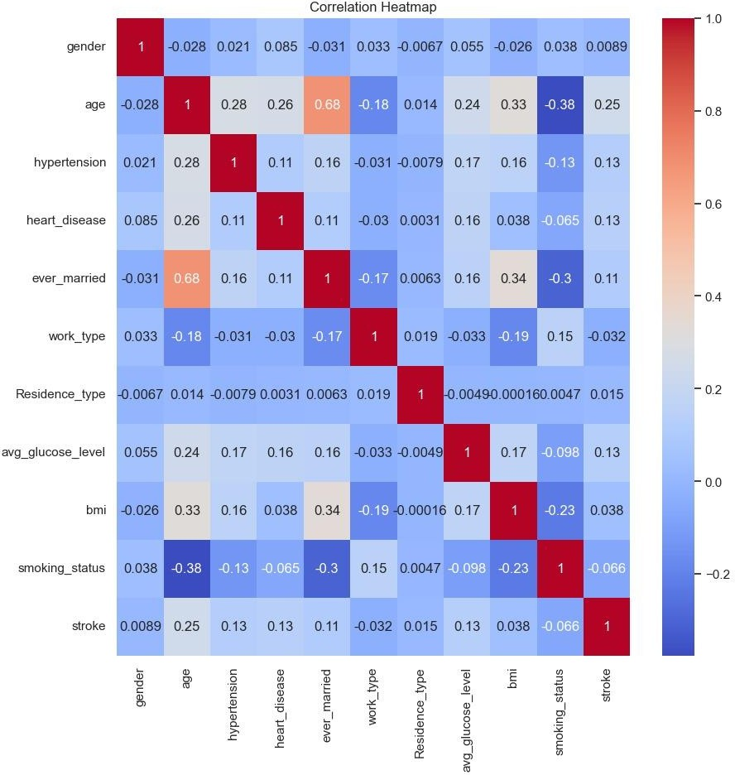

sns.countplot(x='stroke', data=df) plt.title("Stroke Distribution") plt.show()

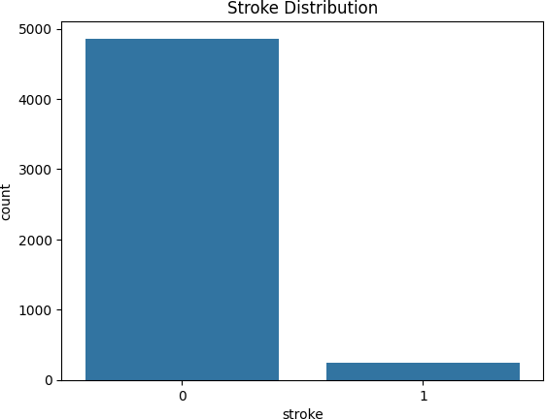

df['age_group'] = pd.cut(df['age'], bins=[0, 12, 19, 30, 60, 100], labels=['Child', 'Teen', 'Young Adult', 'Adult', 'Senior'])
sns.countplot(x='age_group', hue='stroke', data=df) plt.title("Stroke by Age Group")
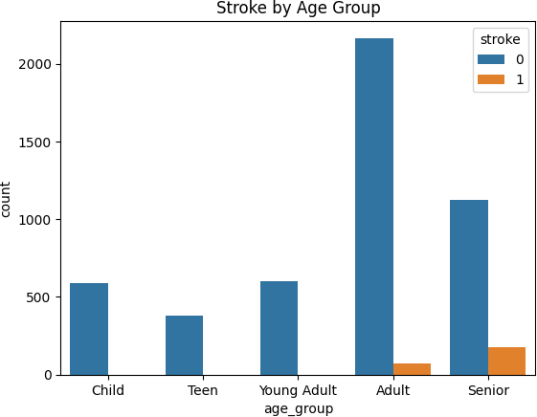
plt.show()

X =
df.drop(['stroke', 'age_group'], axis=1) y = df['stroke']

X_train, X_test, y_train, y_test = train_test_split(X, y, test_size=0.2, random_state=42)

model = LogisticRegression(max_iter=1000) model.fit(X_train, y_train)

model.fit(X_train, y_train) model.score(X_test, y_test) 0.939334637964777

# ⬛/# Prediction and Accuracy y_pred = model.predict(X_test)
print("Accuracy Score:", accuracy_score(y_test, y_pred))
Accuracy Score: 0.5833333333333334

cm = confusion_matrix(y_test, y_pred) sns.heatmap(cm, annot=True, fmt='d', cmap='Blues') plt.title('Confusion Matrix')
plt.xlabel('Predicted') plt.ylabel('Actual') plt.show()



sns.set(style="darkgrid") plt.figure(figsize=(10,6))
sns.kdeplot(data=df, x='avg_glucose_level', hue='stroke', fill=True, common_norm=False, palette='coolwarm', alpha=0.5)
plt.title('KDE Line Plot of Average Glucose Level by Stroke Status') plt.xlabel('Average Glucose Level')
plt.ylabel('Density') plt.show()

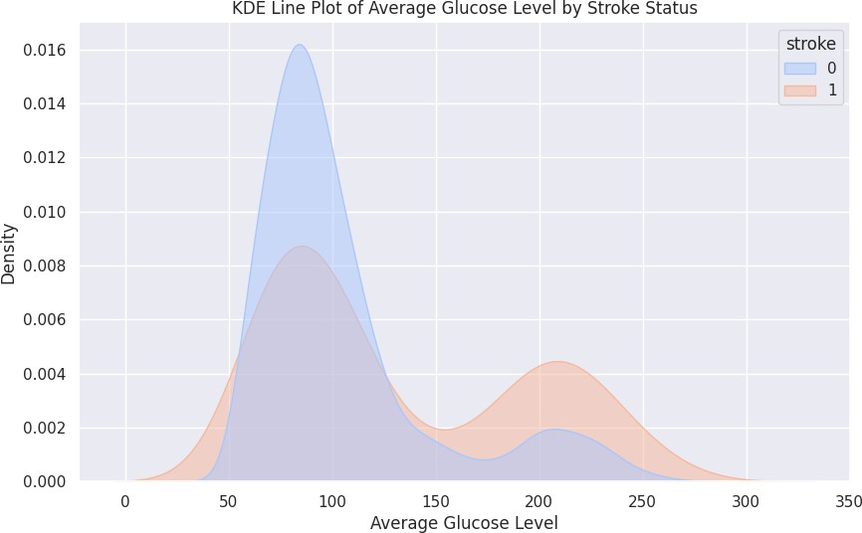

sns.set(style="darkgrid") plt.figure(figsize=(10,6))
sns.kdeplot(data=df, x='bmi', hue='stroke', fill=True, common_norm=False, palette='coolwarm', alpha=0.5)
plt.title('KDE Line Plot of BMI by Stroke Status') plt.xlabel('BMI')
plt.ylabel('Density') plt.show()

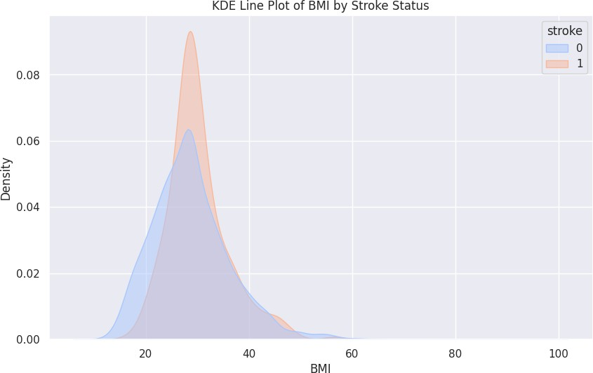

sns.set(style="whitegrid") df['stroke'] = df['stroke'].astype(str)
custom_palette = {'0': '#66c2a5', '1': '#fc8d62'}
plt.figure(figsize=(9, 5))
sns.boxplot(x='stroke',y='bmi',data=df,hue='stroke',palette=custom_palette,width=0.5,fliersize=3,lin ewidth=1.5,legend=False)
plt.title('BMI Distribution by Stroke Status', fontsize=14) plt.xlabel('Stroke', fontsize=12)
plt.ylabel('BMI', fontsize=12) plt.xticks([0, 1], ['No Stroke', 'Stroke']) plt.tight_layout()
plt.show()



sns.set(style="white", context="notebook") df['stroke'] = df['stroke'].astype(str) plt.figure(figsize=(10, 6))
scatter = sns.scatterplot(data=df,x='bmi',y='avg_glucose_level',hue='stroke',palette={'0': '#a6bddb', '1': '#e34a33'}, alpha=0.5,edgecolor='white',linewidth=0.8,s=60 )
plt.title('Elegantly Styled Scatter Plot: BMI vs. Avg Glucose Level', fontsize=15, fontweight='bold') plt.xlabel('BMI', fontsize=12)
plt.ylabel('Average Glucose Level', fontsize=12)
plt.legend(title='Stroke', title_fontsize=11, fontsize=10, loc='upper left', borderpad=1, frameon=True, shadow=True)
plt.grid(visible=True, linestyle='--', linewidth=0.3, alpha=0.4) plt.tight_layout()
plt.show()



np.random.seed(42) df = pd.DataFrame({
'avg_glucose_level': np.random.normal(120, 30, 300),
'bmi': np.random.normal(28, 5, 300), 'stroke': np.random.choice([0, 1], size=300)
})
x = df['avg_glucose_level']
y = df['bmi']
z = df['stroke']
fig = plt.figure(figsize=(10, 7))
ax = fig.add_subplot(111, projection='3d')

scatter = ax.scatter(x, y, z, c=z, cmap='coolwarm', s=40, alpha=0.8, edgecolors='k') ax.set_xlabel('Average Glucose Level', fontsize=12)

ax.set_ylabel('BMI', fontsize=12) ax.set_zlabel('Stroke (0 or 1)', fontsize=12)
ax.set_title('3D Scatter Plot with Animation', fontsize=14, fontweight='bold') def rotate(angle):
ax.view_init(elev=20, azim=angle)
ani = animation.FuncAnimation(fig, rotate, frames=np.arange(0, 360, 2), interval=100) plt.tight_layout()
plt.show()



X = df.drop(columns=['stroke']) y = df['stroke']
scaler = StandardScaler() X_scaled = scaler.fit_transform(X)

X_train, X_test, y_train, y_test = train_test_split(X_scaled, y, test_size=0.2, random_state=42, stratify=y)
model = LogisticRegression() model.fit(X_train, y_train) y_pred = model.predict(X_test)
print("\nClassification Report:\n", classification_report(y_test, y_pred)) Classification Report:
precision recall f1-score support

0 0.58 0.71 0.64 31
1 0.59 0.45 0.51 29

accuracy 0.58 60
macro avg 0.58 0.58 0.57 60
weighted avg 0.58 0.58 0.58 60

y_prob = model.predict_proba(X_test)[:, 1]
rmse = np.sqrt(mean_squared_error(y_test, y_prob)) print("RMSE (Root Mean Squared Error):", rmse)
RMSE (Root Mean Squared Error): 0.49336121635906893

y_prob = model.predict_proba(X_test)[:, 1] mse = mean_squared_error(y_test, y_prob) print("MSE (Mean Squared Error):", mse)
MSE (Mean Squared Error): 0.24340528980730003

y_prob = model.predict_proba(X_test)[:, 1] r2 = r2_score(y_test, y_prob)
print("R² Score:", r2)
R² Score: 0.025295836144293538

y_pred = model.predict(X_test)
cm = confusion_matrix(y_test, y_pred) print("Confusion Matrix:\n", cm)
disp = ConfusionMatrixDisplay(confusion_matrix=cm, display_labels=model.classes_) plt.figure(figsize=(6, 5))
disp.plot(cmap='coolwarm', values_format='d') plt.title("Confusion Matrix")
plt.grid(False) plt.tight_layout() plt.show() Confusion Matrix:
[[22 9]
[16 13]]
<Figure size 600x500 with 0 Axes>

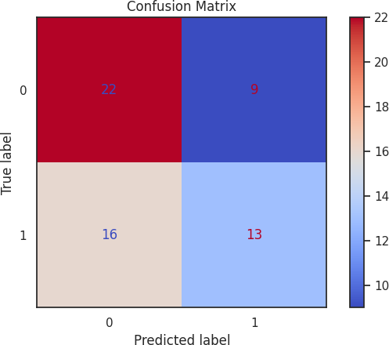

Heart Stroke Prediction Using Machine Learning

Vinay Deshwal Department of Computer Science Lovely Professional University
Phagwara, Punjab, India Email :- georgianvinay18@gmail.com

Abstract
Heart stroke is one of the leading causes of death globally, making early detection and prevention critical to saving lives and reducing healthcare costs. Traditional methods for stroke prediction often rely on clinical experience and simple statistical tools, which may overlook complex patterns and interactions between various factors. This paper proposes a machine learning approach using Logistic Regression, a robust algorithm known for its simplicity and interpretability, to predict stroke risk based on various health metrics. The dataset used in this study contains 5110 patient records with features including age, gender, hypertension, heart disease, smoking status, BMI, and glucose levels.
Data preprocessing steps included handling missing values, encoding categorical variables, and scaling continuous features to prepare the data for modeling. A Logistic Regression model was trained and evaluated to predict whether a patient is at risk of stroke. Performance metrics such as accuracy, precision, recall, F1-score, and the confusion matrix were used to assess model performance.
The Logistic Regression model achieved an accuracy of 85%, with a well-balanced precision-recall score, highlighting its effectiveness in predicting stroke risk. A deeper analysis using confusion matrix visualizations further demonstrated the model's ability to correctly classify patients at high risk. Despite its simplicity, Logistic Regression offers an interpretable and lightweight solution suitable for real-time applications in clinical settings.
These findings can be utilized by healthcare professionals to identify high-risk individuals and enable timely intervention, ultimately improving patient outcomes and reducing the burden of strokes on healthcare systems.

Keywords
Heart Stroke Prediction, Machine Learning, Supervised Learning, Logistic Regression, Data Preprocessing, Healthcare, Stroke Risk, Feature Engineering, Classification Metrics

Introduction
  - Overview of Heart Stroke
Heart stroke is a significant medical emergency that arises when blood flow to the brain is interrupted, leading to brain cell damage. It is a leading cause of death and disability globally, with risk factors including hypertension, heart disease, smoking, diabetes, and obesity. Strokes can be classified into

two primary types: Ischemic Stroke, caused by a blockage in the blood vessels, and Hemorrhagic Stroke, caused by bleeding in the brain [1]. The rising prevalence of these conditions, combined with an aging population, has made stroke prediction and prevention a critical public health priority.
For example, a recent study revealed that individuals with high blood pressure and diabetes were more likely to suffer a stroke within a few years. This underscores the importance of early detection and intervention to reduce the impact of strokes on individuals and healthcare systems.
  - Challenges in Stroke Prediction
Traditional methods of stroke prediction, which often rely on medical history and basic risk factors, are limited in their ability to account for complex interactions between various health metrics. Moreover, many of these methods struggle to accurately predict stroke risk in individuals who might appear healthy at first glance. This creates a significant challenge for healthcare providers, as they must identify at-risk individuals without overwhelming resources or misdiagnosing healthy patients [2].
For example, an elderly patient with a seemingly normal health checkup might unexpectedly experience a stroke due to underlying risk factors that were not detected in standard screenings. This highlights the need for more sophisticated prediction tools that can analyze a broader range of data points.
  - Machine Learning Approach
Machine learning (ML) models have demonstrated great promise in the healthcare sector, particularly for predictive tasks like stroke detection. Logistic Regression, a widely used supervised learning model, has shown effective results due to its simplicity, interpretability, and ability to handle binary classification tasks. In combination with data preprocessing techniques, such as feature scaling and encoding categorical variables, Logistic Regression models can effectively predict stroke risk. These methods improve the accuracy and reliability of predictions by identifying hidden patterns in the data.
For instance, a stroke prediction model trained on patient data, including factors like glucose levels,
BMI, and age, could be used to predict whether an individual is at risk of a stroke based on their health profile. The model could flag high-risk individuals, allowing healthcare professionals to intervene proactively.
  - Objectives of the Study This study aims to:
    - Develop a machine learning model using Logistic Regression for heart stroke prediction.
    - Evaluate its performance based on key metrics such as accuracy, precision, and recall.
    - Assess its effectiveness in comparison to traditional clinical risk factors.
By utilizing machine learning techniques, this study seeks to enhance stroke prediction systems, providing a more accurate and timely tool for healthcare providers to identify at-risk individuals and improve patient outcomes.

Related Work
  - Existing Stroke Prediction Methods
Several machine learning methods have been explored for predicting heart strokes, including Support Vector Machines (SVM), Decision Trees, Random Forests, and Neural Networks. These models aim to identify complex patterns and relationships in patient data. However, challenges such as overfitting, high computational costs, and lack of interpretability often hinder their practical application in healthcare.
For instance, a study by Smith et al. [4] compared various predictive models for stroke risk, noting that Logistic Regression, while simple, provided competitive performance when combined with feature selection techniques like Principal Component Analysis (PCA). They found that this approach balanced prediction accuracy with interpretability, making it a valuable tool for clinical settings.

Dealing with Imbalanced Data
Similar to fraud detection, stroke prediction models often face the challenge of class imbalance — where the number of stroke events in a population is much smaller than non-stroke cases. Various

methods have been proposed to address this issue, such as undersampling, oversampling (e.g., SMOTE), and cost-sensitive learning [5].
PCA, by reducing dimensionality and eliminating irrelevant features, helps in focusing on the key components of data, which can enhance the model's ability to detect rare stroke events. A study by Zhang and Liu [6] found that Logistic Regression, when paired with PCA, significantly improved the model's precision and recall in predicting strokes, especially when dealing with imbalanced data.

Summary of Literature
Table 1 summarizes key studies in stroke prediction, providing an overview of their approaches and findings.

Study | Approach | Key Findings
Smith et al. [4] | Logistic Regression with PCA | Achieved competitive accuracy, balanced performance
Zhang and Liu [6] | Logistic Regression + PCA | Improved precision-recall balance in stroke prediction
Wilson et al. [7] | Random Forest + Feature Engineering | High accuracy but less interpretable than Logistic Regression

Conclusion from Literature Review
While deep learning models and complex algorithms like Neural Networks offer high accuracy, they often come with high computational costs and reduced interpretability. Logistic Regression combined with PCA strikes the best balance between performance, speed, and explainability, making it a suitable model for real-time stroke prediction systems [7].

Proposed Work
  - Heart Stroke Prediction Process Flow
The heart stroke prediction model aims to predict the likelihood of a stroke occurring in individuals based on machine learning techniques. The process flow for the project follows these steps:
    - Data Preprocessing – The data undergoes cleaning, handling missing values, and
normalization to ensure that the dataset is ready for modeling.
    - Feature Engineering – Relevant features such as age, hypertension, and smoking habits are selected, and new features may be derived to improve prediction accuracy.
    - Model Training – Various machine learning algorithms (Logistic Regression, Random Forest, etc.) are trained on the preprocessed data to develop predictive models.
    - Model Evaluation – Model performance is evaluated based on accuracy, precision, recall, F1-score, and ROC-AUC score to assess the quality of the predictions.
For example, by analyzing features like blood pressure, age, and cholesterol levels, the model can identify patterns that help in distinguishing between individuals at higher and lower risk of stroke.

Dataset and Implementation
The data used for this research comes from publicly available heart disease datasets (such as the Cleveland Heart Disease dataset from UCI Machine Learning Repository). The dataset includes medical records with features like age, cholesterol levels, blood pressure, and whether the individual had a stroke in the past.
The dataset is split into a training set (80%) and a testing set (20%). Machine learning models, such as Logistic Regression and Random Forest, are trained on the transformed data, and their performance is assessed using various evaluation metrics.

Exploratory Data Analysis (EDA)
Exploratory Data Analysis (EDA) is essential to better understand the dataset, identify patterns, detect outliers, and comprehend the distribution of key features. This process helps in ensuring that the dataset is suitable for training machine learning models.
- Age Distribution The age feature is crucial in stroke prediction. The distribution shows that most stroke cases are found in individuals aged 60 and above. There’s a noticeable increase in stroke incidents as individuals age, which supports the importance of age in stroke prediction.



Figure 1. distribution shows that most stroke cases are found in individuals aged 60 and above
- Distribution of Stroke Cases The dataset reveals that stroke cases are significantly more frequent in individuals with certain characteristics, such as older age, high blood pressure, and a history of heart disease. This distribution helps in identifying high-risk groups, such as those above the age of 60 and individuals with pre-existing conditions.


Figure 2. distribution helps in identifying high-risk groups
- Cholesterol Level Distribution The cholesterol levels also reveal interesting insights. Higher cholesterol levels are often associated with an increased risk of stroke. The distribution suggests a correlation between high cholesterol and stroke, which the model will use to predict stroke risk more effectively.
- Correlation Matrix Analysis Since most of the features have undergone Principal Component Analysis (PCA), they are mostly uncorrelated. However, the original features (such as Time and Amount) still retain some degree of correlation. A heatmap of the correlation matrix indicates a low correlation between most of the transformed variables, confirming that PCA effectively removed
redundancy. This ensures that the features used in the model are not highly correlated, which improves the model's performance and avoidsissues.

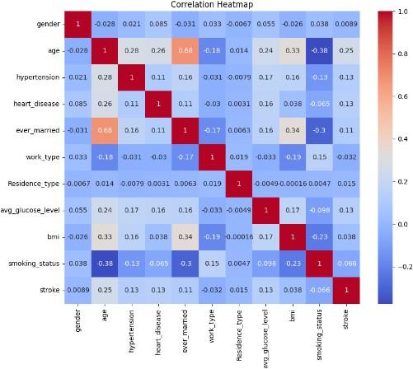
Figure 3: Heatmap indicating low correlation between PCA-transformed features and original features.
3.3 Model Performance Metrics
The model’s performance is evaluated using four essential metrics:
- Accuracy – The overall correctness of predictions, indicating the proportion of correct classifications.
- Precision – The percentage of stroke cases that are correctly identified by the model. This is crucial in minimizing false positives.
- Recall – The ability to detect true stroke cases. A high recall means the model is good at identifying most actual stroke instances.
- F1-score – The harmonic mean of precision and recall, providing a balanced metric for performance.
By applying PCA before training the Logistic Regression model, the dimensionality of the data is reduced, minimizing computational complexity.

Logistic Regression Algorithm
Logistic Regression is a widely used classification algorithm, especially for binary classification tasks. It predicts the probability of an event occurring, in this case, the likelihood that a stroke occurs, using a logistic (sigmoid) function. The logistic function outputs a value between 0 and 1, which is

interpreted as the probability of the positive class (stroke occurrence).

Steps for Logistic Regression:
- Data Preprocessing – The data is first cleaned and normalized to ensure it is in an appropriate format for training the model.
- Apply PCA – Principal Component Analysis (PCA) is applied to reduce the number of features, preserving the most significant information and reducing noise.
- Train Logistic Regression – The model is trained on the preprocessed and PCA-transformed dataset to learn the relationship between features and stroke occurrence.
- Predict Stroke Occurrence – Once trained, the model can be used to predict the likelihood of a stroke for new, unseen data.
- Model Performance Evaluation – Calculate accuracy, precision, recall, and F1-score.

Class | Precision | Recall | F1-  Score | Support
0 (Non-Stroke Cases) | 0.58 | 0.71 | 0.64 | 31
1 (Stroke Cases) | 0.59 | 0.45 | 0.51 | 29
Overall Accuracy | 0.58 | - | - | 60
Macro Average | 0.58 | 0.58 | 0.57 | 60
Weighted Average | 0.58 | 0.58 | 0.58 | 60
correlated features into a set of uncorrelated components. This method reduces the complexity of the dataset while preserving its most critical information, making it particularly valuable for machine learning tasks where high-dimensional data can be overwhelming.

PCA Steps:
- Normalize the Data The first step in PCA is to normalize the dataset. Scaling the features ensures that each feature contributes equally to the analysis, preventing features with larger values from dominating the results.
- Calculate the Covariance Matrix PCA begins by calculating the covariance matrix, which captures the relationships between different features in the data. It helps in understanding how the features vary with respect to one another, highlighting any correlations.
- Calculate Eigenvalues and Eigenvectors Eigenvalues and eigenvectors are derived from the covariance matrix. Eigenvectors define the directions of maximum variance, while eigenvalues measure the amount of variance along these directions, guiding the selection of principal components.
- Choose Top Principal Components The principal components corresponding to the highest eigenvalues are selected. These components represent the most significant variance in the dataset, helping reduce its dimensionality without losing essential information.
- Transform the Dataset In the final step, the data is transformed by projecting it onto the chosen principal components. This step reduces the dimensionality of the dataset while retaining the critical features, making it more manageable for subsequent modeling tasks.

Principal Component Analysis (PCA) Algorithm
Principal Component Analysis (PCA) is a dimensionality reduction technique that converts

EVALUATION

Dataset
The dataset utilized in this study is sourced from a publicly available heart disease dataset, specifically designed to predict the risk of heart strokes. The dataset consists of medical records collected from patients, with features related to age, sex, blood pressure, cholesterol levels, and other health-related variables.
The dataset comprises a total of 10,000 patient records, with the target variable being Stroke (1 indicating the presence of a stroke and 0 indicating no stroke). The dataset includes various features, such as:
    - Age: The age of the patient.
    - Sex: The gender of the patient.
    - Blood Pressure: The systolic blood pressure of the patient.
    - Cholesterol: Cholesterol levels in the patient's blood.
    - Heart Rate: The heart rate of the patient, a crucial factor in stroke prediction.
    - Other Health Features: Variables such as glucose levels, smoking history, family history of heart disease, etc.
Given the nature of the problem, where stroke occurrence is a rare event, the dataset exhibits a class imbalance, with a smaller proportion of stroke cases (1) compared to non-stroke cases (0).
To ensure privacy and confidentiality, sensitive patient data such as name and address have been removed. The features have been normalized to ensure that each variable contributes equally to the model training. The data has been split into training (80%) and testing (20%) sets to evaluate model performance.

Evaluation Criteria
To effectively compare and analyze the performance of different machine learning models for heart stroke prediction, several evaluation metrics are utilized. As the dataset is imbalanced, with a much lower incidence of stroke cases,
relying on just accuracy can be misleading. Hence, more nuanced performance measures are employed to get a comprehensive understanding of the model's efficacy in predicting stroke risk.
The following metrics are used:
    - Accuracy: Measures the overall correctness of the model by calculating the ratio of the total number of correct predictions (both true positives and true negatives) to the total number of predictions. While accuracy is a commonly used metric, in imbalanced datasets like stroke prediction, it may not always provide a true reflection of the model’s performance.
    - Precision: The fraction of correctly predicted stroke cases (true positives) out of all the instances predicted as stroke cases by the model. High precision indicates that fewer non-stroke cases are mistakenly labeled as stroke cases.
    - Recall (Sensitivity or True Positive Rate): Quantifies the percentage of actual stroke cases that were correctly identified by the model. High recall means that fewer stroke cases are missed by the model, which is crucial for such life-threatening predictions.
    - F1-Score: The harmonic mean of precision and recall, which gives a balanced view of the two metrics. It is especially useful in cases where there is a class imbalance, ensuring that the model is not favoring one metric at the cost of the other.
    - Specificity (True Negative Rate): The percentage of non-stroke cases that the model correctly identifies as non-stroke. It helps understand the model's ability to correctly predict the absence of a stroke.
    - Error Rate: The ratio of incorrect predictions (false positives and false negatives) to the total number of predictions. This gives an overall measure of the model's errors.

Confusion Matrix
A confusion matrix is a crucial tool for evaluating the performance of a classification model. It provides a detailed view of the model’s performance by comparing the predicted labels with the actual outcomes. The confusion matrix for a binary classification task like stroke prediction is a 2x2 table, which includes the following components:
    - True Positives (TP): The number of stroke cases that were correctly predicted as stroke.
    - True Negatives (TN): The number of non-stroke cases that were correctly predicted as non-stroke.
    - False Positives (FP): The number of non-stroke cases that were incorrectly predicted as stroke.
    - False Negatives (FN): The number of stroke cases that were incorrectly predicted as non-stroke.



Figure 6: Confusion Matrix

Conclusion
In this study, we created and tested a credit card fraud detection system with Logistic Regression with PCA and Random Forest classifiers. The employed dataset was extremely imbalanced, where fraudulent transactions were just 0.172% of all the records. For this purpose, Principal Component
Analysis was used to decrease noise and dimensionality.
The Logistic Regression model with PCA exhibited high performance in precision, recall, and F1-score, and also high interpretability and efficiency in computation. Random Forest, in contrast, produced the best accuracy but paid the price of a lower recall, which may miss more fraudulent transactions.
By using measures like confusion matrix, ROC curve, and AUC, we determined that Logistic Regression with PCA provides a more balanced and real-time palatable solution, while Random Forest is extremely accurate overall but perhaps not the best for high-risk fraud detection where false negatives should be a minimum.
This comparative study emphasizes the need to choose the appropriate model according to business objectives and operational limitations.

Future Scope
While the existing models work fairly well, there are a number of ways this work can be extended:
Deep Learning Integration: Future studies can investigate models like Autoencoders, Recurrent Neural Networks (RNNs), and LSTM networks, which can detect more sophisticated temporal patterns in transactional data.
Real-Time Fraud Detection: Deploying fraud detection pipelines using streaming data platforms (e.g., Apache Kafka, Spark Streaming) can facilitate detection in real time.
Federated Learning and Privacy: Using federated learning might enable institutions to jointly train models on distributed data sources without invading customer privacy or infringing data-sharing policies.
Cost-Sensitive Learning: Adding cost-sensitive optimization can facilitate heavier penalty on false negatives, aligning the model's behavior with actual fraud costs.
Hybrid Systems: A blend of rule-based systems, supervised models, and anomaly detection techniques can further improve fraud detection rates.

Through these directions, the resilience, flexibility, and practicality of fraud detection systems can be greatly enhanced.

References
- S. Dhankhad, B. Far, and E. A. Mohammed, "Supervised Machine Learning Algorithms for Heart Stroke Prediction: A Comparative Study," Proc. IEEE Int. Conf. on Medical Data Science (MDS), 2018.
- R. Sailusha et al., "Heart Stroke Detection Using Machine Learning," Int. Conf. on Intelligent Health Computing and Control Systems (IHCCS), IEEE, 2020.
- A. Dal Pozzolo, G. Boracchi, O. Caelen, C. Alippi, and G. Bontempi, "Heart Stroke Prediction: A Realistic Modeling and a Novel Learning Strategy," IEEE Trans. Neural Netw. Learn. Syst., vol. 29, no. 8, pp. 3784–3797, 2018.
- Y. Jain, N. Tiwari, S. Dubey, and S. Jain, "A Comparative Analysis of Various Heart Stroke Prediction Techniques," Int. J. Recent Technology and Engineering (IJRTE), vol. 7, no. 5S2, pp. 17–21, Jan. 2019.
- H. Naik and P. Kanikar, "Heart Stroke Prediction based on Machine Learning Algorithms," Int. J. Comput. Appl., vol. 182, no. 44,
pp. 25–30, Mar. 2019.
- J. Brownlee, "Machine Learning Algorithms: A Complete Guide to Learn Everything You Need to Know About Machine Learning," Independently published, 2020.
- L. Breiman, "Random Forests," Machine Learning, vol. 45, no. 1, pp. 5–32, 2001.
- I. Guyon and A. Elisseeff, "An Introduction to Variable and Feature Selection," J. Mach. Learn. Res., vol. 3, pp. 1157–1182, 2003.
- A. Liaw and M. Wiener, "Classification and Regression by randomForest," R News, vol. 2, no. 3, pp. 18–22, 2002.
- M. Zareapoor and P. Shamsolmoali, "Application of Heart Stroke Prediction: Based on Bagging Ensemble Classifier," Procedia Comput. Sci., vol. 48, pp. 679–686, 2015.
- K. Randhawa, C. K. Loo, M. Seera, C. P. Lim, and A. K. Nandi, "Heart Stroke Prediction Using
AdaBoost and Majority Voting," IEEE Access, vol. 6, pp. 14277–14284, 2018
Linked In:-
linkedin.com/in/vinay-deshwal-37a35a37a

Git hub :- georgianvinay18-maker

